Ideation Phase
Empathize & Discover

Date | 19 February 2026
Team ID | LTVIP2026TMIDS35300
Project Name | Civil Engineering Insight Studio
Maximum Marks | 4 Marks

Empathy Map Canvas
An empathy map helps understand the target users by analyzing their behaviors, goals, frustrations, and needs.
For this project, the primary users are:
- Civil Engineers
- Construction Supervisors
- Project Managers
- Structural Inspectors

Target User Persona
User Type: Civil Engineer / Construction Supervisor
Work Environment: Construction sites, infrastructure projects, engineering offices
Primary Goal: Quickly analyze and document structural details from site images

Empathy Map for Civil Engineering Insight Studio
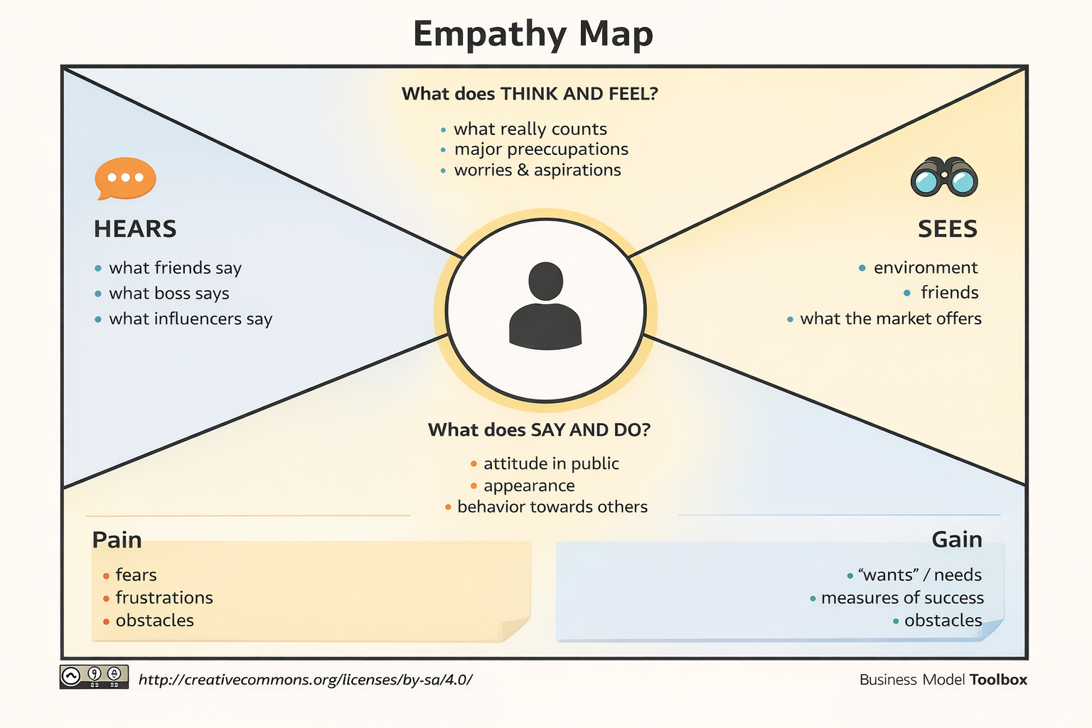

Empathy Insights Summary

User Goals
- Reduce time spent on manual structural description
- Improve documentation accuracy
- Identify materials and components easily
- Monitor construction progress efficiently

User Challenges
- Handling large-scale projects
- Identifying materials visually
- Maintaining structured documentation
- Managing deadlines

Opportunity Identified
There is a strong need for an AI-powered tool that:
- Analyzes images automatically
- Identifies materials and structural components
- Generates structured engineering descriptions
- Assists in project progress tracking
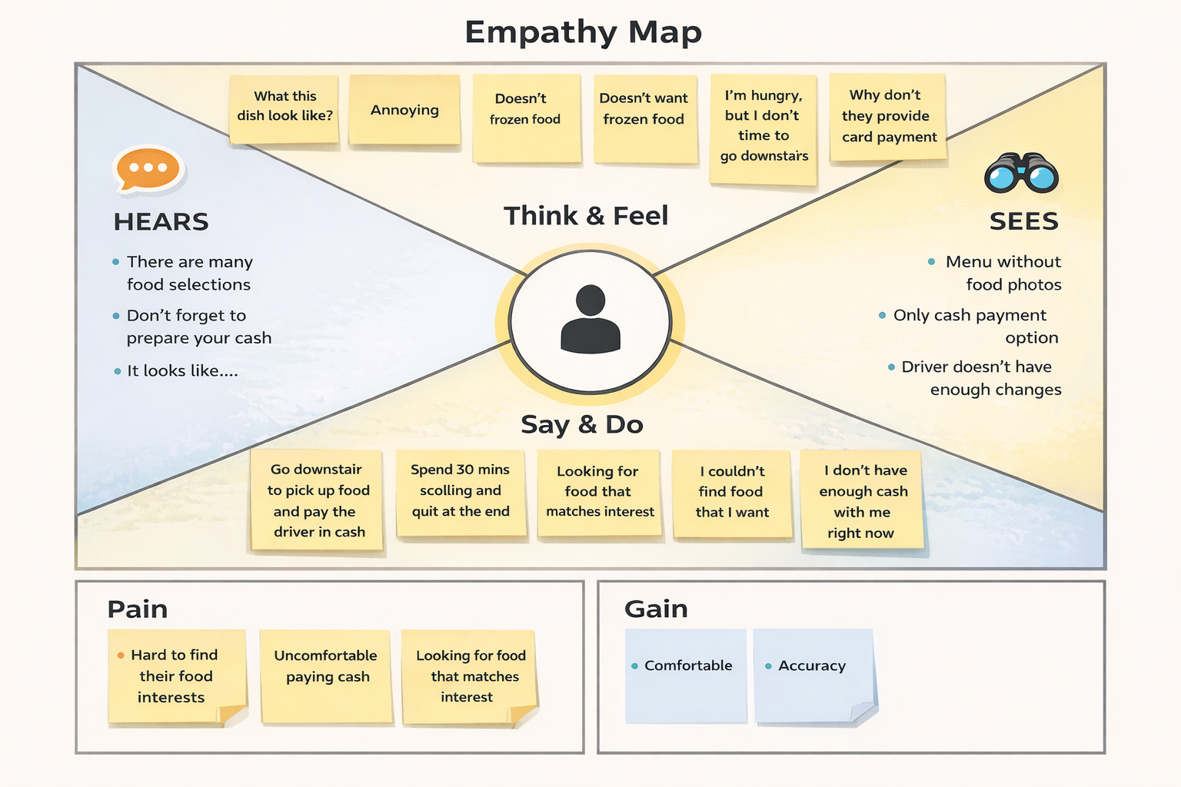

How Civil Engineering Insight Studio Solves This
The solution integrates AI-based image analysis using Gemini to:
- Detect structural components
- Identify construction materials
- Generate detailed reports
- Highlight engineering challenges
- Improve workflow efficiency

Conclusion of Empathize Phase
Through the empathy mapping exercise, we identified that civil engineers struggle with:
- Time pressure
- Manual documentation burden
- Risk of human error
- Inconsistent structural analysis
The Civil Engineering Insight Studio addresses these issues by providing an intelligent, automated, and reliable structural insight generation system.

